

Knapsack problem using genetic algorithm

Abstract:
Genetic algorithms (GAs) are stochastic search algorithms that mimic the biological process of evolution enabling thereby users to solve complex optimization problems. They operate based on a population of chromosomes, where a chromosome represents a candidate solution. Genetic operators allow the population to evolve over time and to converge to the optimal solution. In the spirit of “survival of the ﬁttest,” GAs are naturally designed to solve maximization problems in which chromosomes with high ﬁtness are more likely to survive and the objective function is termed ﬁtness function. The ﬁtness function is a mathematical expression that evaluates the “quality” of a chromosome and steers the evolutionary search toward high ﬁtness regions in the given search space. Note that the search space is usually a multi-dimensional space that consists of all candidate solutions. Two appealing properties of GAs are that they require no derivatives of the objective function and they are capable of performing global optimization. The former is in particular useful in situations in which, for example, no derivatives of the objective function exist and hence conventional techniques like gradient decent methods can–because of their very nature–not be applied. Given an unlimited amount of search time, GAs are able to ﬁnd the global optimum in the search space. That is because they are less likely to get trapped in a local maximum due to their intrinsic stochastic mechanisms.

The Knapsack Problem:
A SGA is probably the best known GA design, where chromosomes are represented as a binary string like ‘1010001’. The zeros and ones are the genes of a binary chromosome, and their meaning depends on the problem one tries to solve. To apply a SGA to a given optimization problem, an initial population of binary strings is ﬁrst created in a random manner, subsequently the quality of each chromosome is evaluated using the ﬁtness function. Based on the ﬁtness values, a selection is done in such a way that high ﬁtness chromosomes have a higher probability of being selected into the mating pool than low ﬁtness chromosomes. The mating pool represents the foundation for breeding new candidate solutions. Chromosomes selected into the mating pools are also called parents.
Once the mating pool is created, a crossover is performed in order to exchange gene material between parents, which in turn creates new chromosomes, also called oﬀspring or children. In SGAs, single-point crossover is a popular genetic operator that often used to perform the crossover for binary-encoded chromosomes. That is, with a probability pc, two parents are randomly selected from the mating pool, as well as a single crossover point between 1 and l−1 is randomly determined, where l is the length of the chromosome. The children are then created by exchanging the genes of the parents after the crossover point.
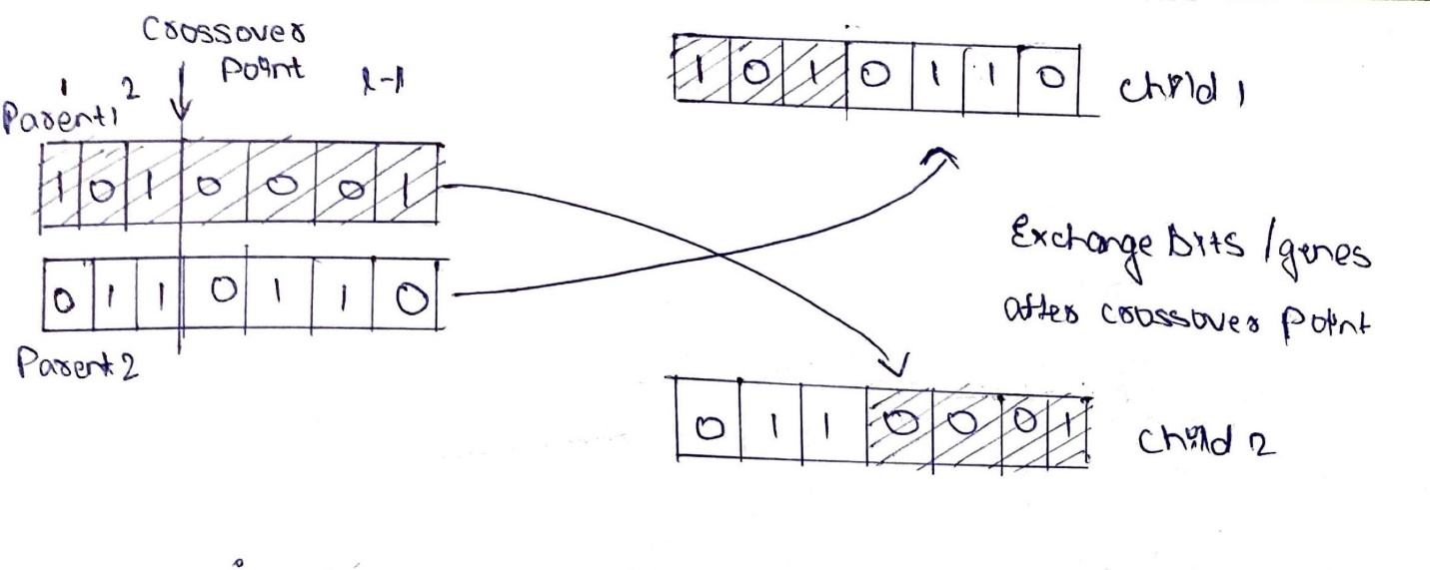Next, mutation is applied to introduce a higher diversity into the population. The induced randomness of this genetic operator is useful because it helps to explore the search space and enables the SGA to escape local optima. A common operator is the bit-flip mutation. Similar to crossover, a chromosome is randomly selected with probability pm from the processed mating pool. The selected chromosome can either be a parent or a child. Then, a gene j of the selected chromosome is randomly picked and its value is flipped over, i.e., 0 becomes 1 and 1 becomes 0. A mutant is then a genetically modified chromosome as a result of the mutation operator. Thus, the mating pool now consists of parents (chromosomes that have been selected but neither undergo crossover nor mutation), children (new chromosomes resulting from crossing parents), and mutants (new chromosomes resulting from mutating parents or children). In the SGA implementation that we are going to use, pc and pm are by default set to 0.8 and 0.1, respectively. Thus, the lion’s share of the processed mating pool are likely children. In the next step, the fitness of children and mutants is evaluated.
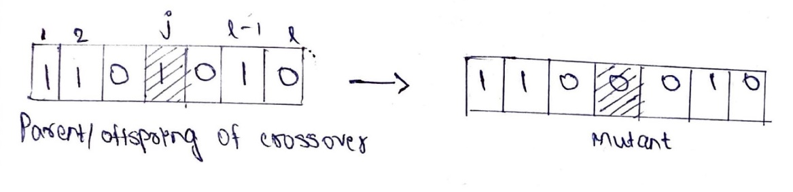
After having applied the genetic operators, the population is updated to the next generation, and the SGAs converges to the (global) maximum one generation at a time. The update is conducted as follows: the mating pool obtained in the previous step is in principle the next generation. However, often SGAs utilize a mechanism called elitism which ensures that a certain proportion of the fittest chromosomes of the current population survives to the next generation. In other words, chromosomes with the lowest fitness in the mating pool are substituted with the fittest chromosomes of the current population. Once having done this, the mating pool becomes the next population, and the algorithm iterates. The advantage of elitism is that it increases the selective pressure among the chromosomes that compete for survival across generations and helps to maintain a high quality fitness level in the population, as well as keeping track of the best solution obtained so far. The steps outlined above are carried out repeatedly until a predefined number of maximum generations is reached or—commonly also applied—the best fitness function value has not improved for a predetermined number of generations. If a termination criterion is met, the SGA returns the fittest population member, which represents the final solution.
Given its zero-one encoding scheme, SGAs are naturally applicable to solve the knapsack problem. The knapsack problem aims to maximize the total profit for a selection of items, each with a profit pi and a weight wi, from a given item set of size n, while simultaneously preventing the violation of the constraint that the total weight of selected items exceeds the knapsack’s capacity W.

Let f(·) represent the fitness function and x = (x1,…,xn) be a binary vector, indicating selected items, i.e., xi = 1 if the ith item is selected into the knapsack, and xi = 0 otherwise (note that this example, as well as the following mathematical formulations and code, have been adapted from [2, 3]). The knapsack problem can be formally described as follows:
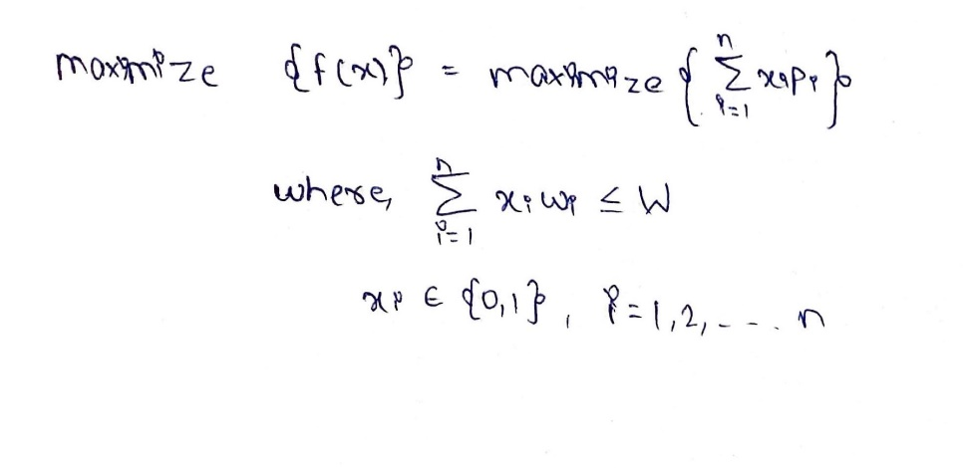
where we seek to find x∗ = argmax{f(x)} which represents the final solution, revealing which items to select for maximum profit under the capacity constraint. 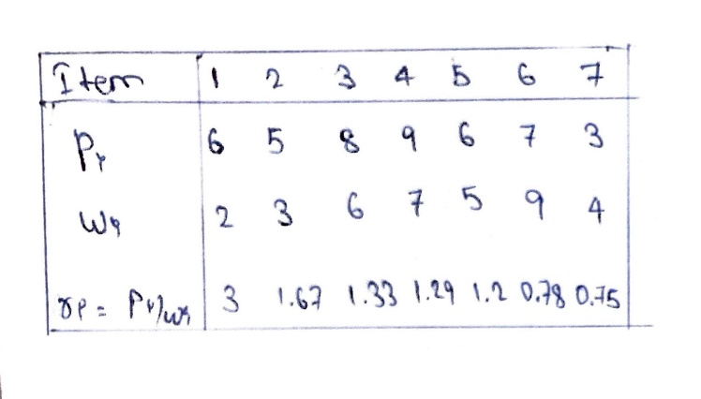

Intuitively, it makes sense to select items with low weight and high profit for the knapsack. To facilitate the picking, we can compute the ratio r_{i} of profit to weight for each item. When proceeding in a greedy fashion, we first pick the item with the highest r_{i}, then the second highest, and so on, until the constraint is met. According to this method, the solution consists of the items {1,2,7}, yielding a total profit of Σ⁷_{i=1} x_{i}p_{i} = 14 and a total weight of Σ⁷_{i=1} x_{i}w_{i} = 9

In conclusion, GAs are powerful meta-algorithms inspired by natural selection that can be used for solving complex optimization problems. Here, we only discussed the application to one instance of constrained optimization: the knapsack problem. In a simple example, we demonstrated that the SGA solution yields a higher total profit than the greedy approach, where both solutions exhibit the same total weight at the capacity limit. Last but not least, we briefly outlined how the knapsack problem can be adapted to a feature selection problem in which a SGA can be utilized to find the globally best set of features.

Algorithm Explanation:
The algorithm starts by creating 100 random arrays with size 5. This array consists of binary values 0's and 1's. The selection method runs after the initialization and selects the best 50 arrays with the best fitness. The best fitness is a method which checks each array for the correspondence weight and profit. Those two arrays contain the weight and the profit for each index of the parents array which is 1. Now the mutation method randomizes those arrays for optimization purposes. In this case, my method generates random numbers for each index for each array with range 0,1. Then it checks if the value is less than 0.5 and if true, it swaps the index from 0 to 1 or 1 to 0. Next method which takes place in the running time is the crossover which mixes two parents (arrays) and makes children. The purpose of this method is to create back 100 parents for further iteration of the algorithm as well as find the optimal value of profits we are looking for. The program stops when we found the optimal value otherwise generates again new children until it finds the optimal which in this case is [0, 1, 1, 1, 0].

